

Flex Student Portal

Muhammad Hadi Shahid - 22k5024  
Aheed Khan – 22k-5018  
Lucky – 22k5144

*Submitted to:*

Sir Basit Jasani

Department of Computer Science BS(CS)

FAST-NUCES Karachi

## 1. Project Description:

The **Flex Student Portal** is designed to streamline and enhance student interactions with institutional systems by offering a unified platform. This project addresses the challenges of scattered and manual processes for managing attendance, course marks, and feedback, among other academic operations. Its main objective is to simplify academic management for students, instructors, and administrators by providing an efficient, user-friendly interface. The portal includes features such as attendance tracking, course management, and evaluation feedback, catering to the needs of students and staff at the University.

## 2. Features of the Project

1. **Dynamically Saving and Storing Data**: Allows real-time data entry and updates, ensuring seamless user interaction and data persistence in the database.
2. **Image Saving in Database**: Facilitates storing and retrieving student or teacher profile pictures securely in a Binary format.
3. **Hashing Password**: Secures user passwords using hashing algorithms ensuring stored passwords are not readable.
4. **Timetable Management for Students**: Provides personalized timetables based on enrolled courses, displaying class schedules, timings, and locations.
5. **Showing Student Data**: Displays comprehensive student profiles, including personal information, academic history, and enrolled courses.
6. **Course Registration for Students and Teachers**: Enables students to enroll in courses and teachers to assign themselves to courses for a given term.
7. **Managing and Viewing Attendance**: Tracks and displays attendance records, allowing students and teachers to monitor attendance history and compliance.
8. **Managing Transcript**: Generates and displays official academic transcripts, showing completed courses, grades, and GPA.
9. **Marks Distribution for Students**: Provides a breakdown of marks for assignments, quizzes, and exams, offering a clear view of performance in each course.
10. **Challan Information**: Generates and tracks fee challans for tuition and other expenses, allowing students to view and download payment details.
11. **Changing Password for Website**: Allows users to update their passwords securely via the portal.
12. **Drop and Add Courses for Teachers**: Enables teachers to modify their assigned courses by adding new ones or dropping current ones during the registration period.
13. **Withdraw Courses for Students**: Allows students to withdraw from courses within a specified period, updating their academic records accordingly.
14. **Managing Course Feedback**: Collects and organizes feedback on courses and instructors from students, aiding in quality improvement.

## 3. Final Entity Relationship Diagram (ERD)

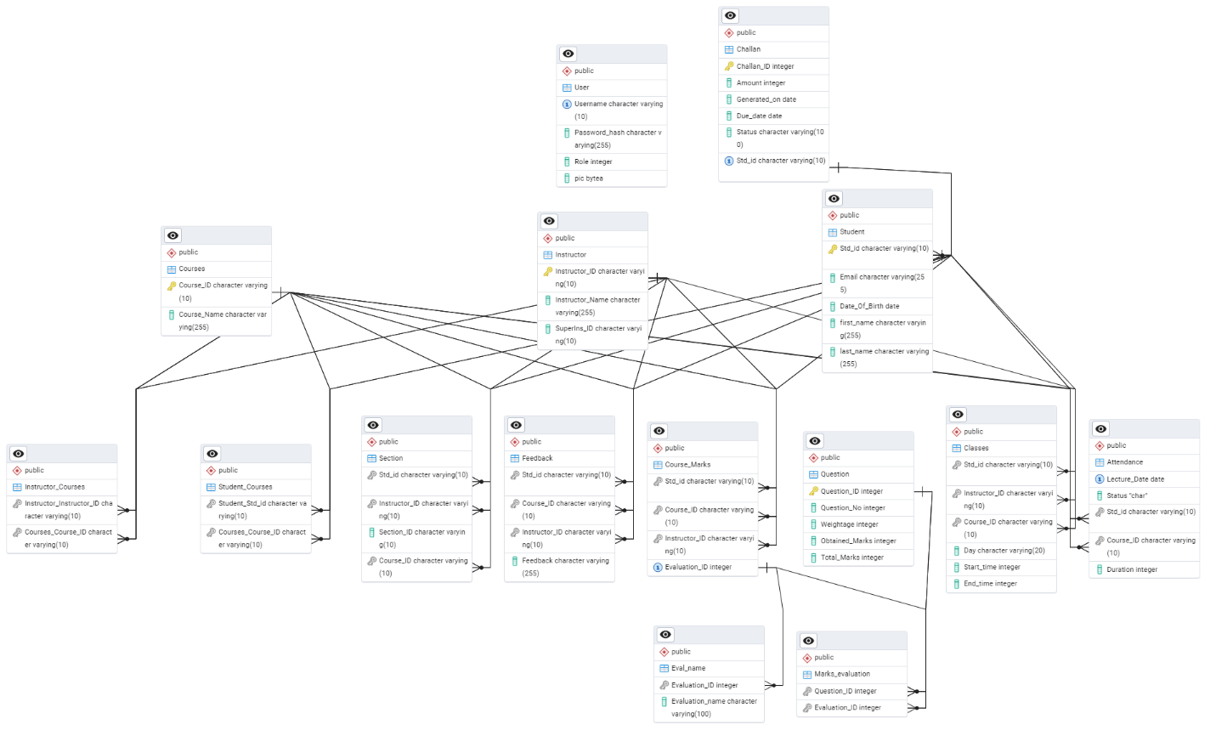

## 4. Normalized Schema Tables

All tables are in 3NF form.

1.Attendance:

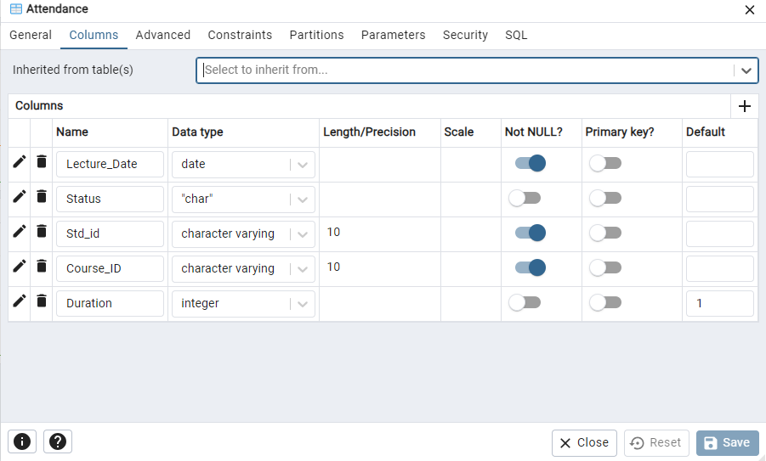

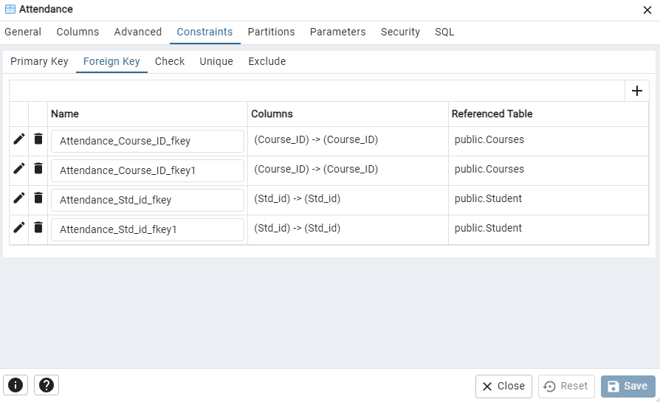

2.Challan:

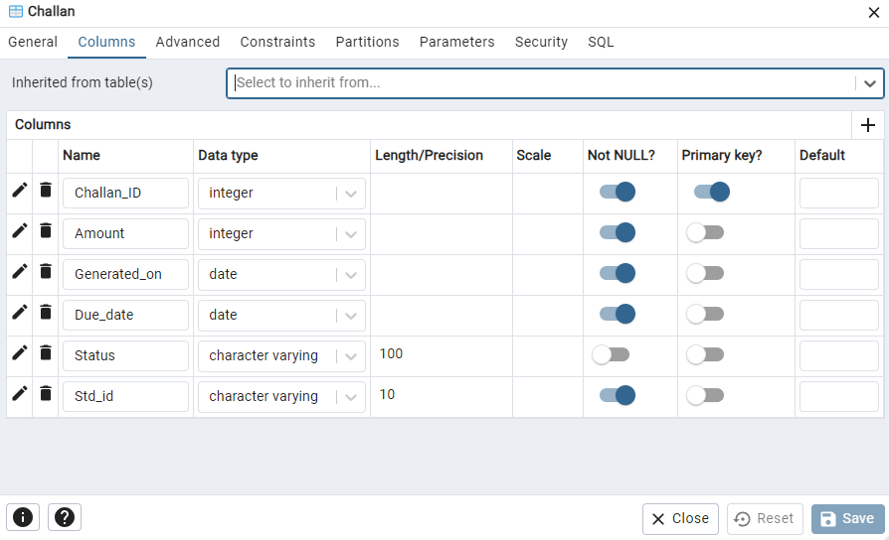

3.Classes:

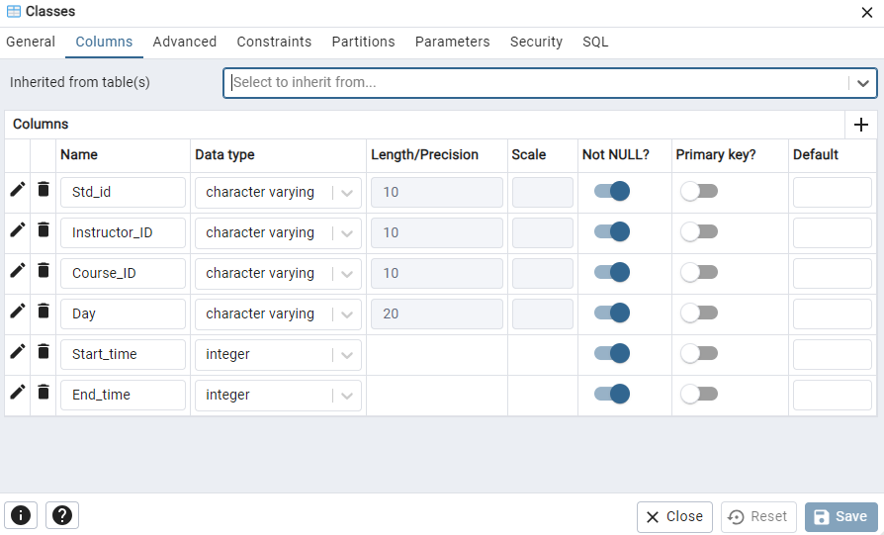

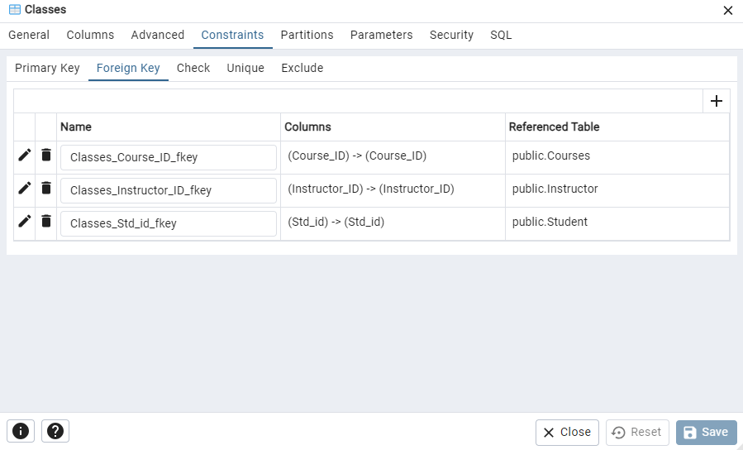

4.Course_Marks:

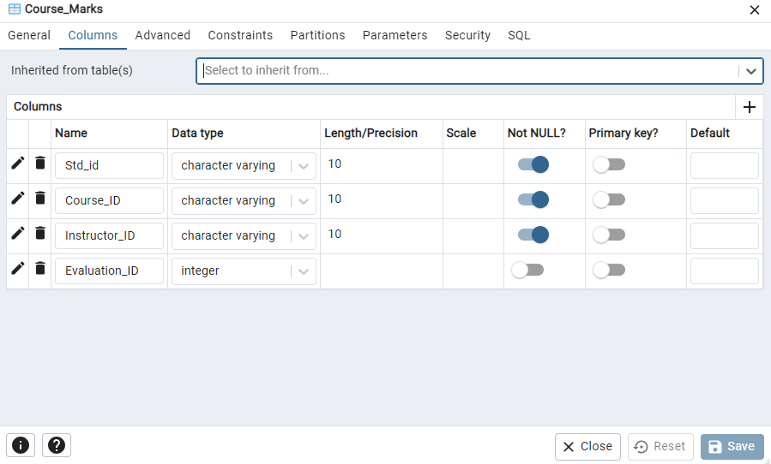

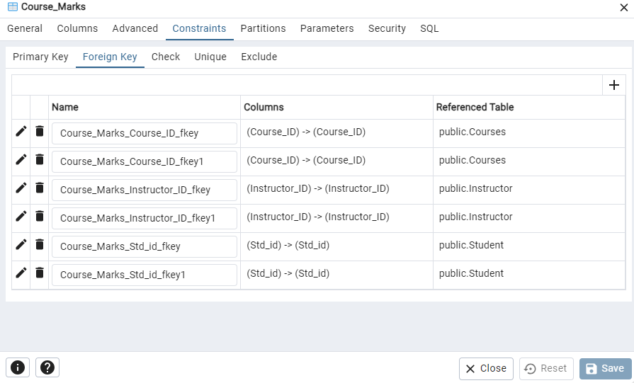

5.Courses:

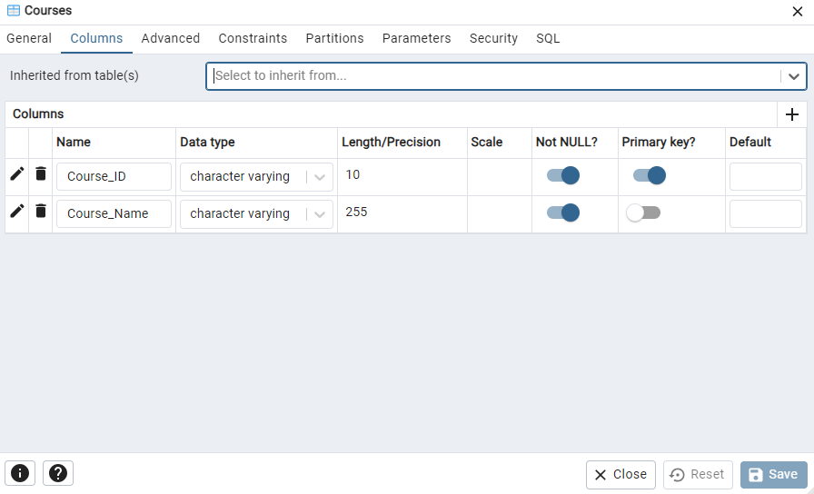

6.Eval_name:

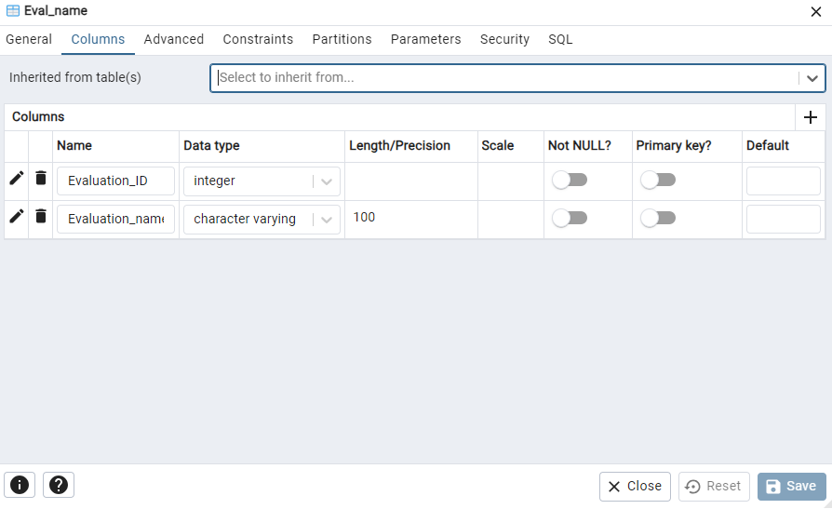

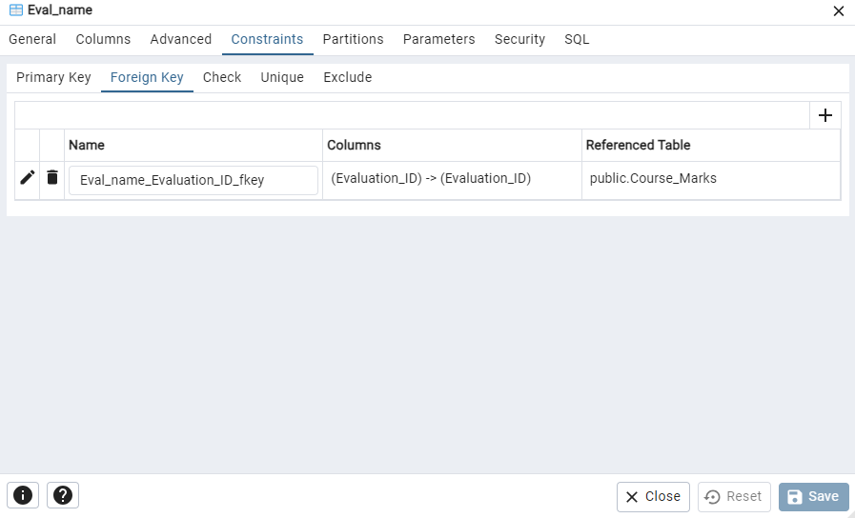

7.Feedback:

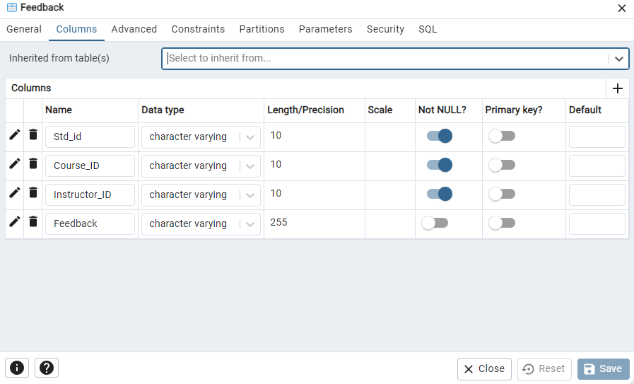

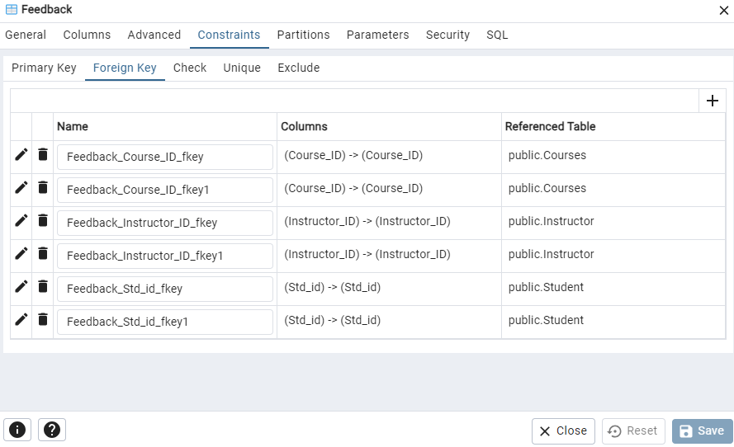

8.Instructor:

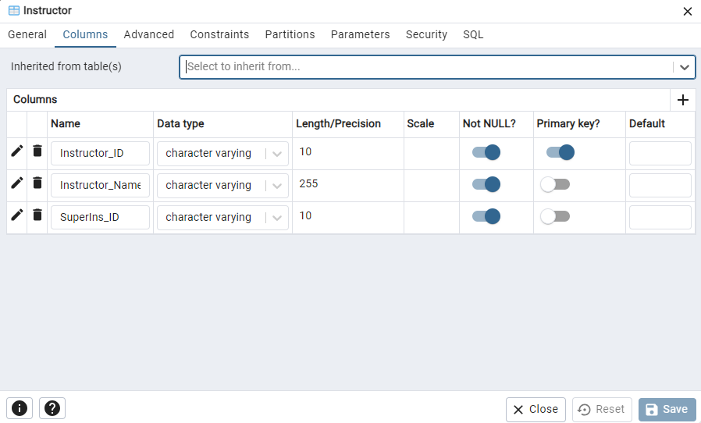

9.Instructor_Courses:

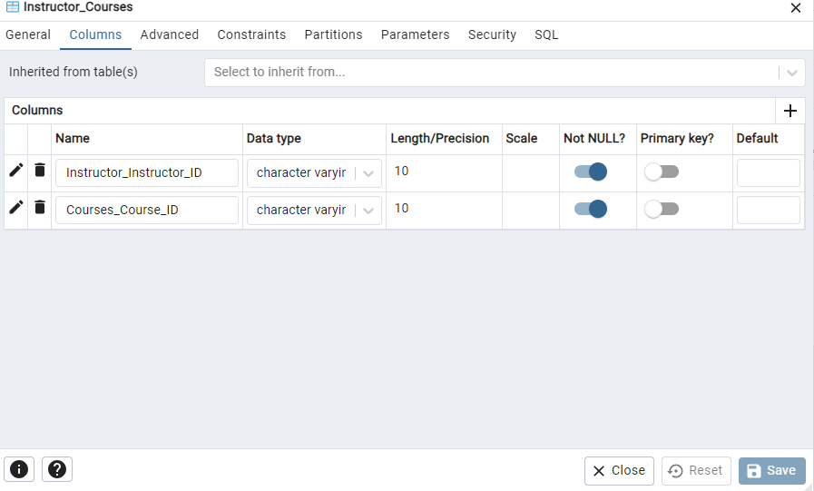

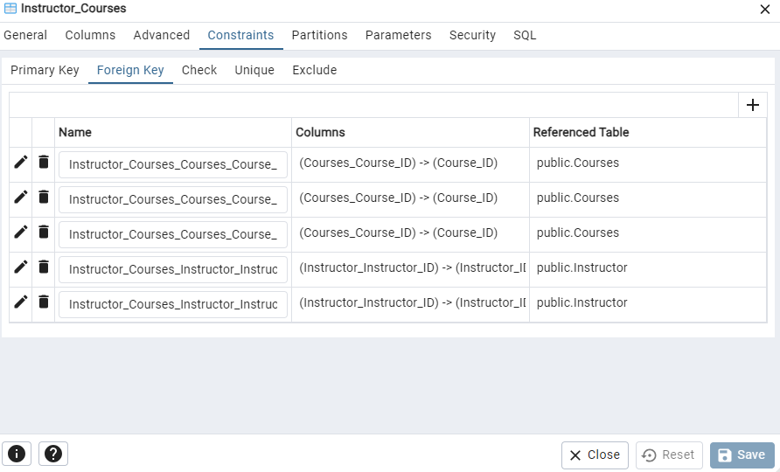

10.Marks_evaluation:

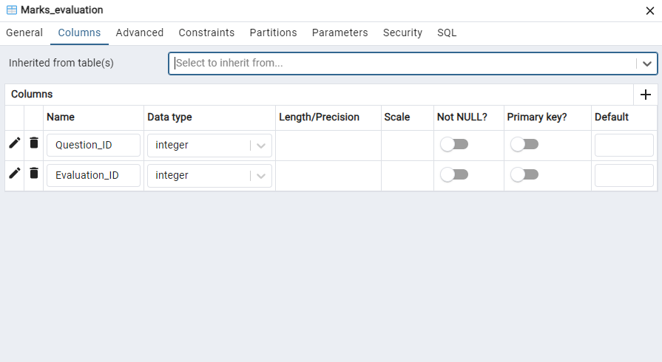

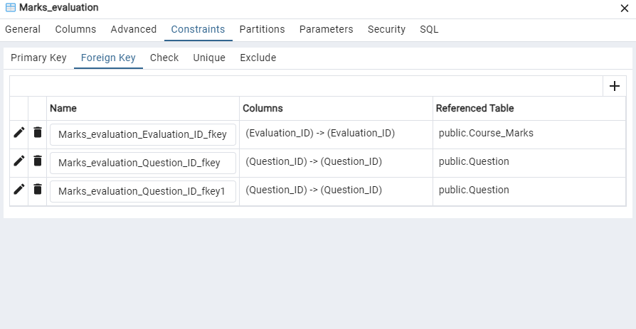

11.Question:

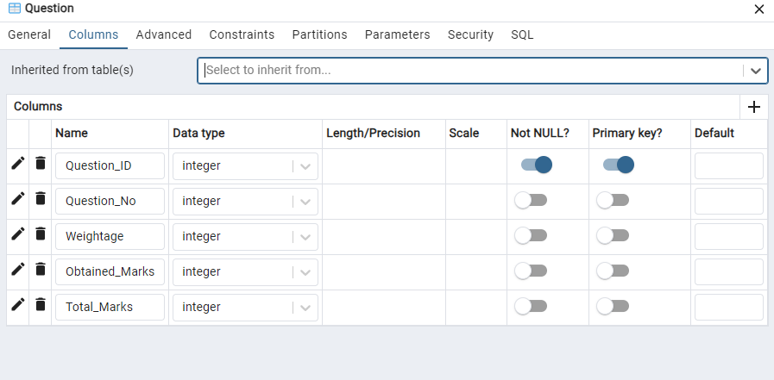

12.Section:

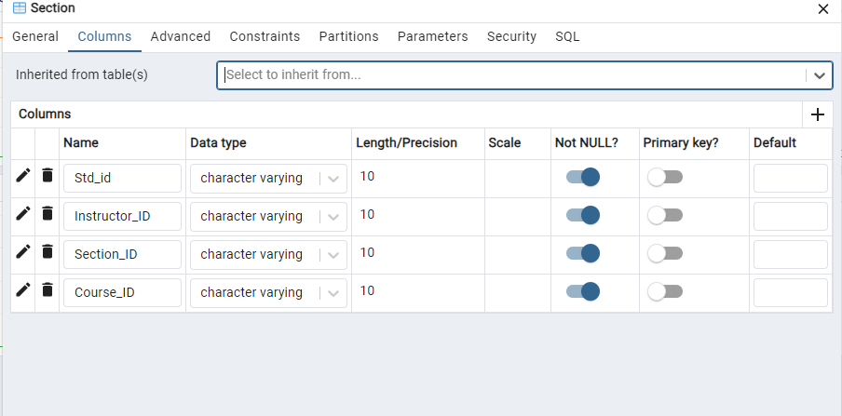

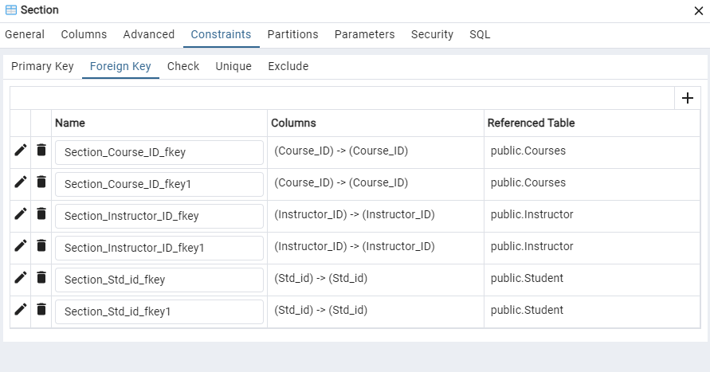

13.Student:

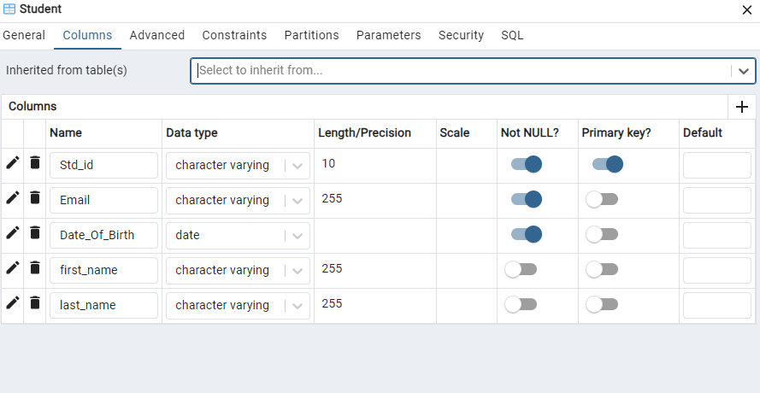

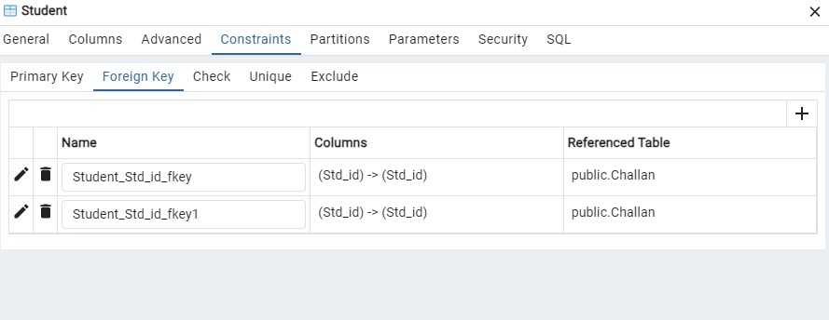

14.Student_Courses:

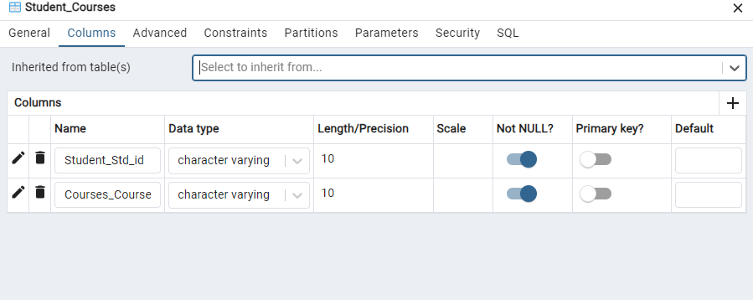

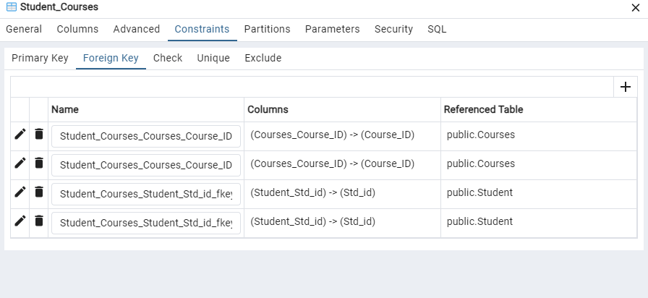

15.User:

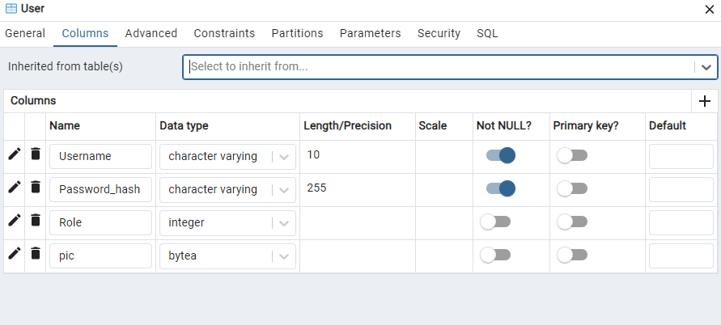

## 5. Mapping Tables to Features:

1.Attendace:Managing Student attendance.

2.Challan:Manage Student Fees.

3.Classes:Used for Managing Timetable.

4.Course_Marks:Joins Course With Marks. Used in marks distribution. Maintains 3NF form.

5.Courses:Manages Student Courses.

6.Eval_name:Stores Evaluation name for Evaluation ID.

7.Feedback:Manages and stores student feedback.

8.Instructor:Stores Instructor information.

9.Instructor_courses:Joins Instructor with courses. Used in many places. Maintains 3NF form.

10.Marks_evaluation:Joins Marks with respective evaluation. Maintains 3NF form.

11.Question:Stores Question information with respect to question ID.

12.Section:Stores Student Section. Used in multiple location to retrieve section ID.

13.Student:Stores Student information.

14.Student_Courses:Joins Student with courses. Used to hold and display Student courses and course registration. Maintains 3NF form.

15.User:Stores user information. Used in password hashing and image storing.

## 6. Conclusion

The **Flex Student Portal** provides an efficient solution for managing student and instructor activities within an academic environment. The database schema supports the seamless execution of all features, with normalization ensuring efficient storage and retrieval of data.

Challenges faced during development included designing a scalable ERD, resolving normalization conflicts, and implementing complex features like evaluation reports. Future improvements could include incorporating predictive analytics for student performance and expanding the portal’s functionalities to support extracurricular activities and alumni management.